**Outcomes-based Training in GIS Techniques and Production of a GIS Mini Project**

Date: June 5-9, 2017

Host and Venue: Sultan Kudarat State University, Tacurong City, Sultan Kudarat

*Instructor: Al Tongco PhD*

*Founding Director of Philippine GIS Data Clearinghouse (www.philgis.org)*

*Email:* [*al\_tongco@yahoo.com*](mailto:al_tongco@yahoo.com;)*, Globe Cell: 0905-332-4448*

**ACT11: Creating a Simple Map Layout**

Purpose: To learn how to create a simple map layout in QGIS

Open QGIS.

Click New tool.

Add Vector Layers SL\_Munis**.shp** and **PHL\_adm2\_PSA\_pn\_2016June.shp** (or equivalent datasets you have used or produced in previous activities. See illustration below.)

Modify the color symbols of the layers.

Add labels to the provinces. Scale-based visibility: Rendering > Max 2000000 approximately.

Add labels to the municipalities. Scale-based visibility: Rendering > Max 1000000 approximately.

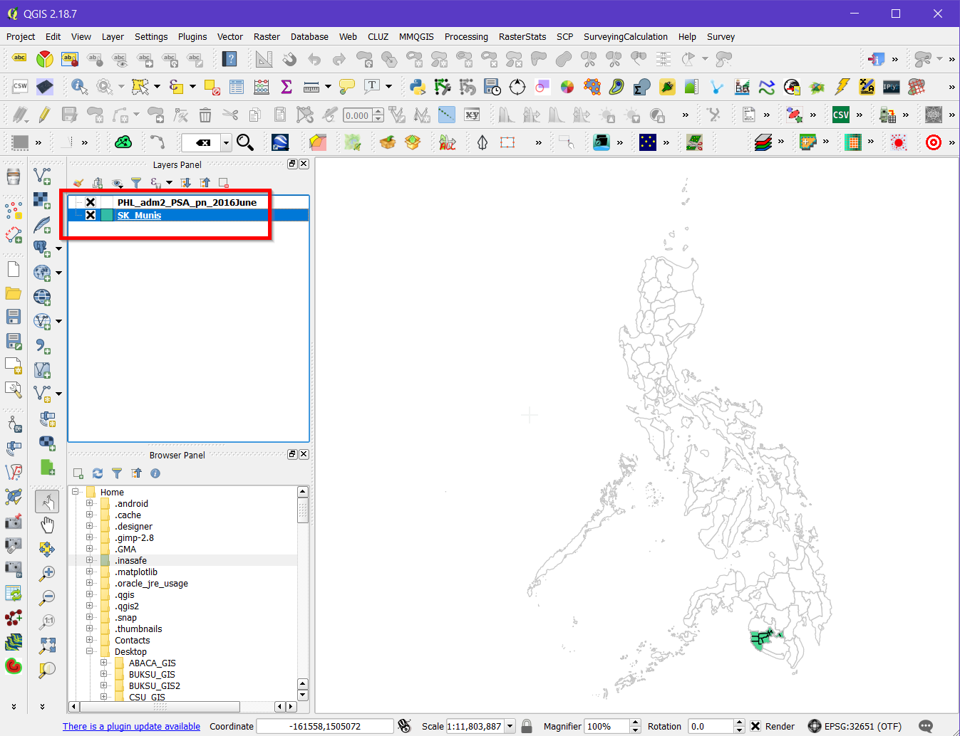

Zoom to Sultan Kudarat and modify the style.

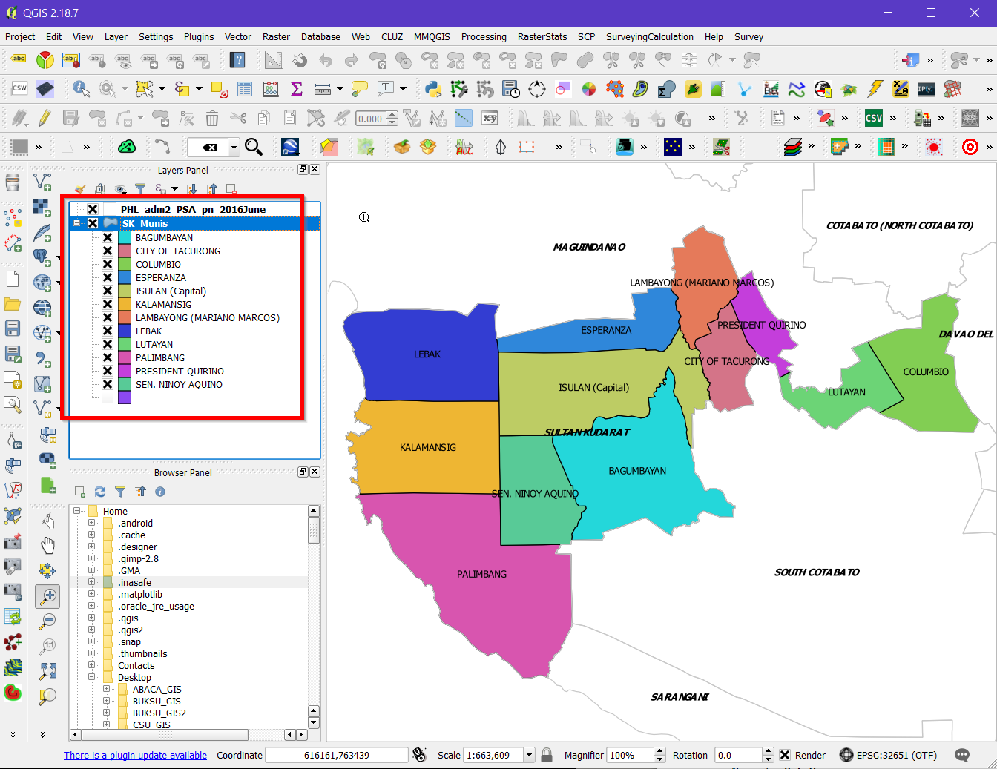

Reproject to WGS 84 (Lat/Long degrees)

Save project as **ACT11\_SL\_SimpleMapLayout.qgs**. Save in C:\…..\OUTPUT\PROJECT\

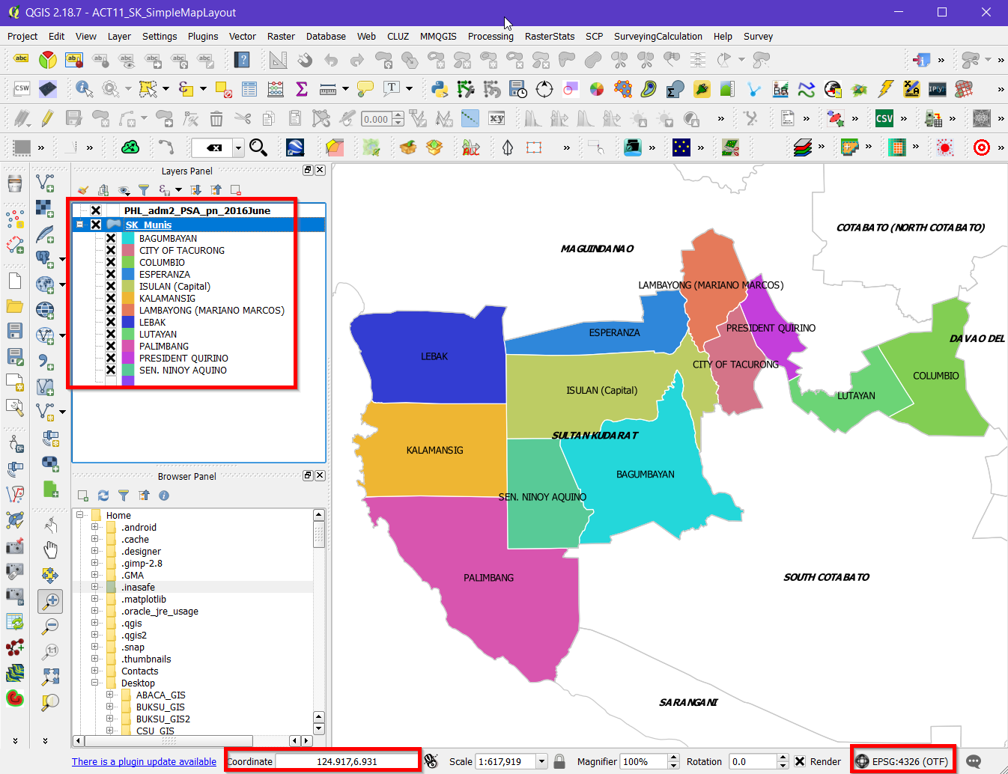

We’ll create a layout for the map like the one above.

Here are the steps:

Click Project > New Print Composer

Name it as **SLTowns.**

The default blank layout opens in Composer window, as shown.

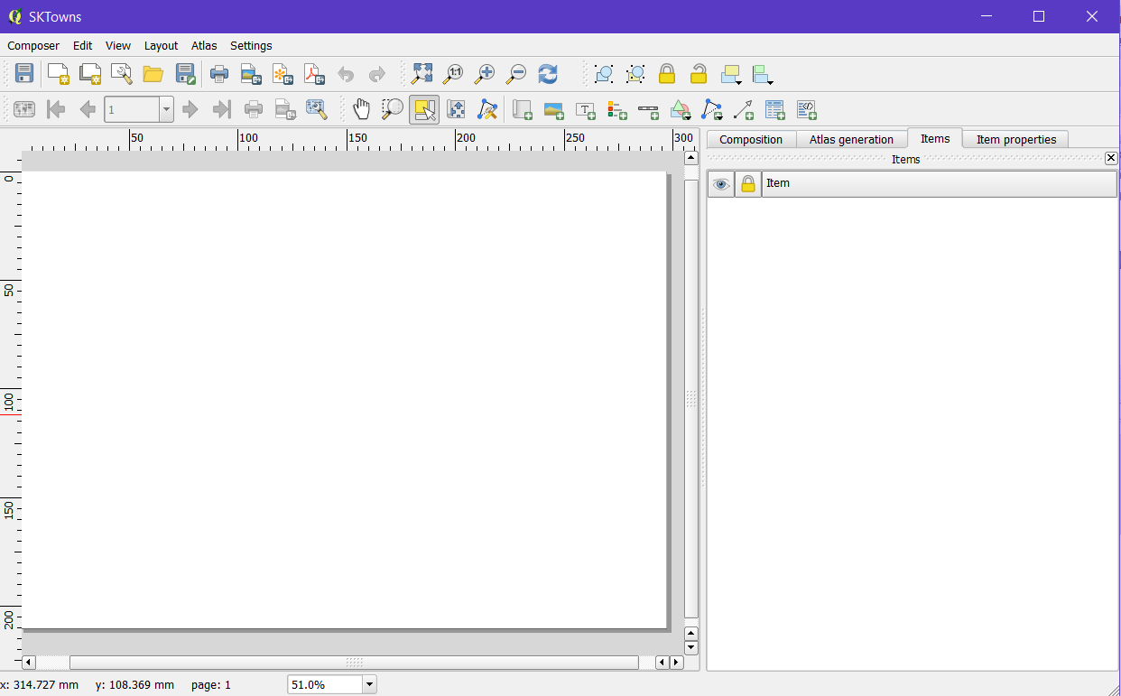

Familiarize with the Menu and Tool bars.

Click ‘Composition’ tab.

Presets: ANSI A

Set the Orientation: Landscape

Export resolution: 600 dpi.

World file on.

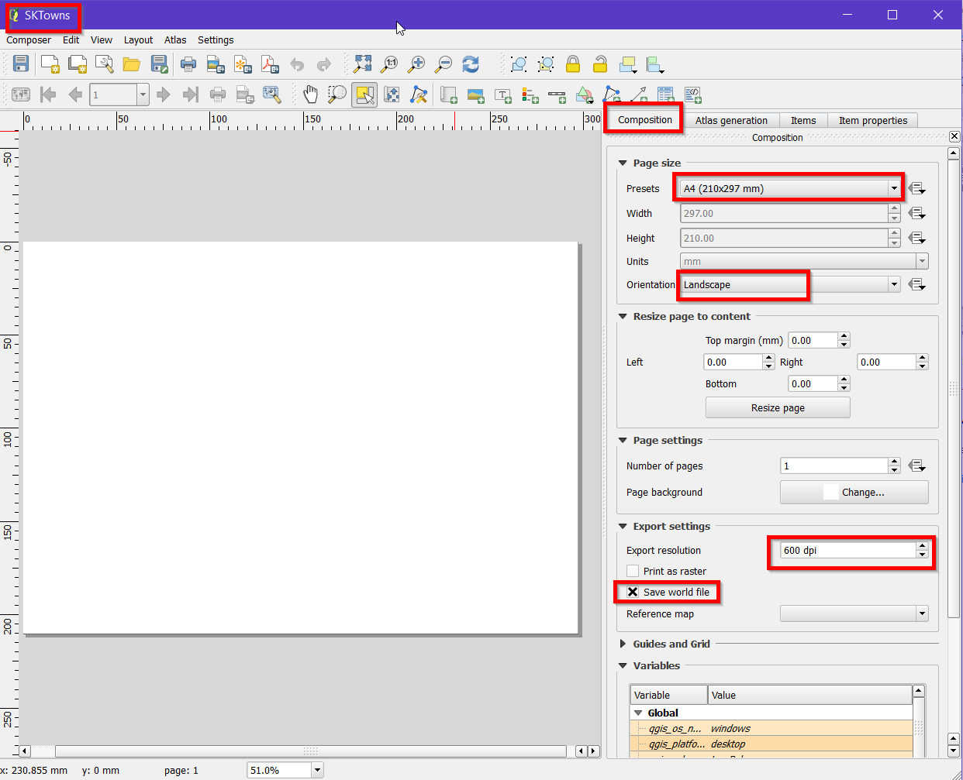

Click ‘Zoom full’ tool.

Click ‘Add new map’ tool 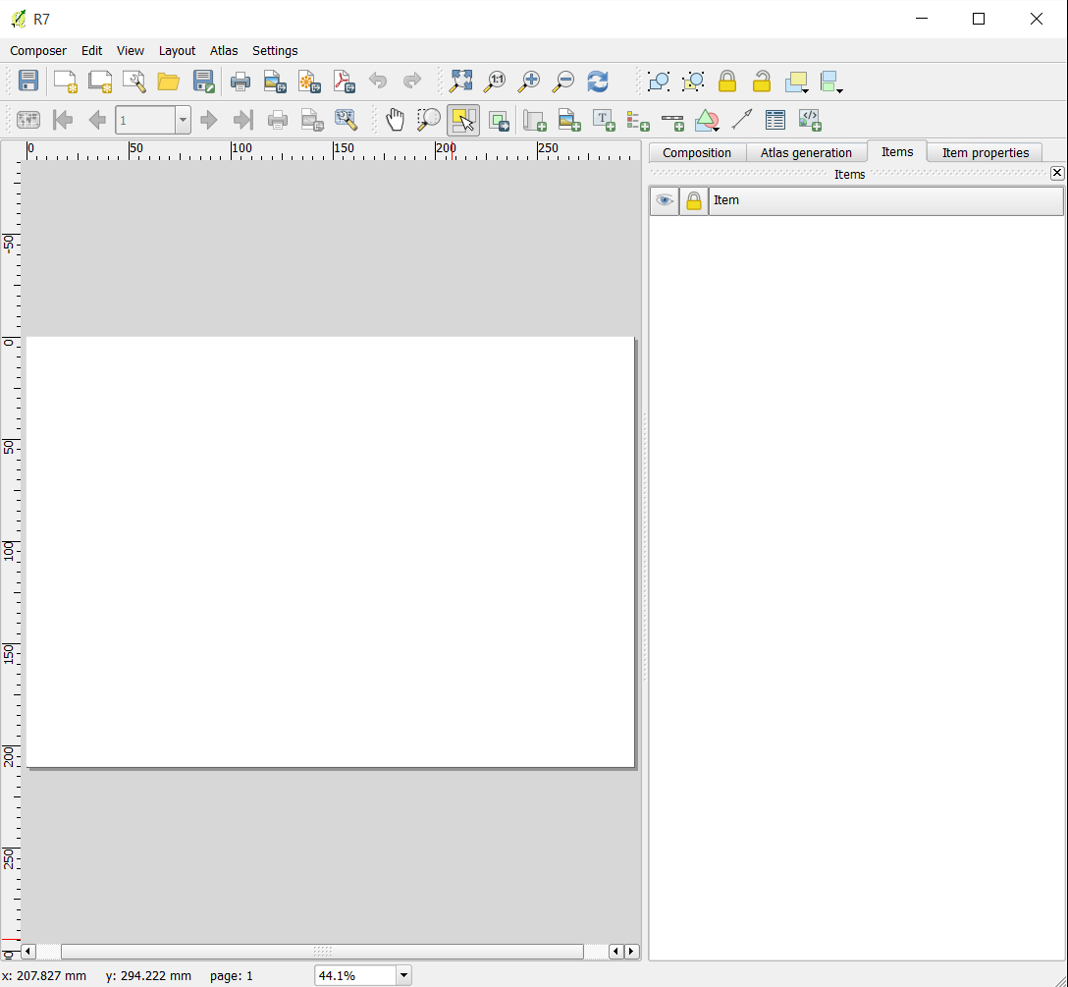.

Drag a full box on the blank layout. Automatically, it displays the activated layers from the Layers Panel. Arrange the layers and apply appropriate symbols so that you will get the illustration similar to one shown below.

Use ‘Move Item Content’ tool to move the map inside the layout.

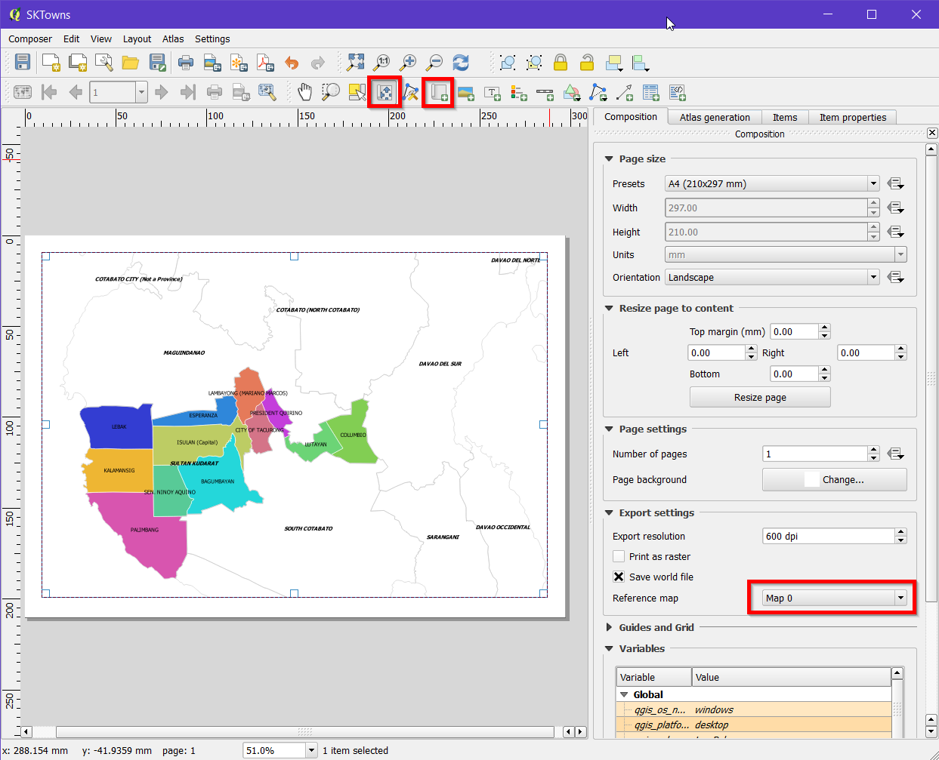

Click ‘Item properties’ tab.

Accept the default for the ‘Extents’.

Expand ‘Grids’.

Add “Grid 1” and draw “Grid 1” grid.

Fill out or modify entries as shown.

You may follow the specs shown below.

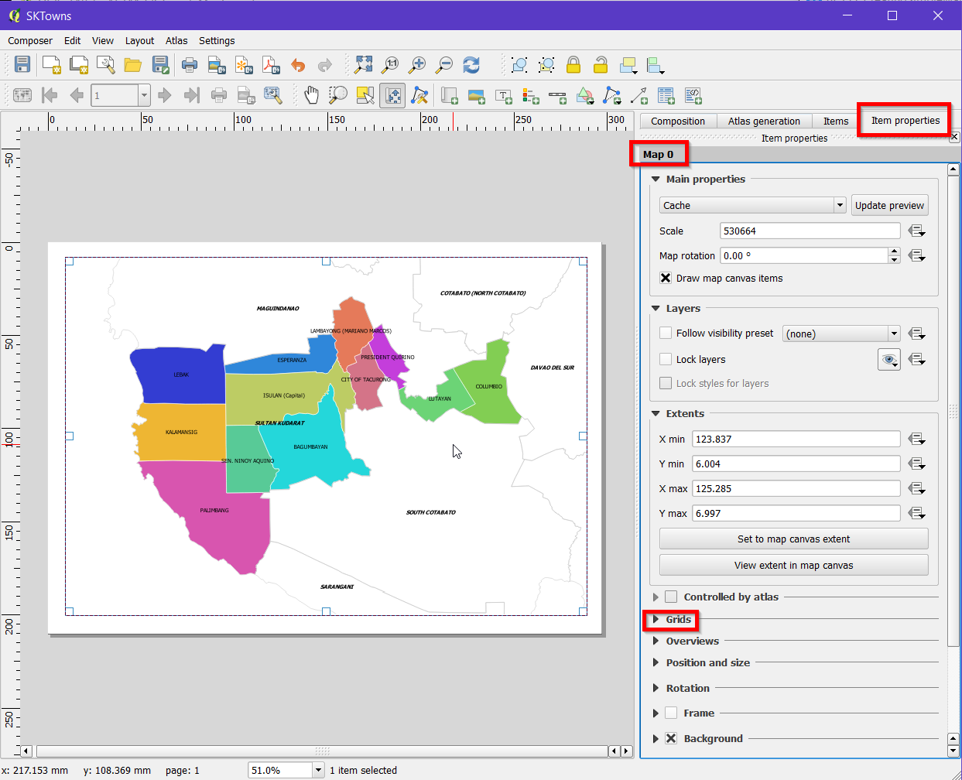

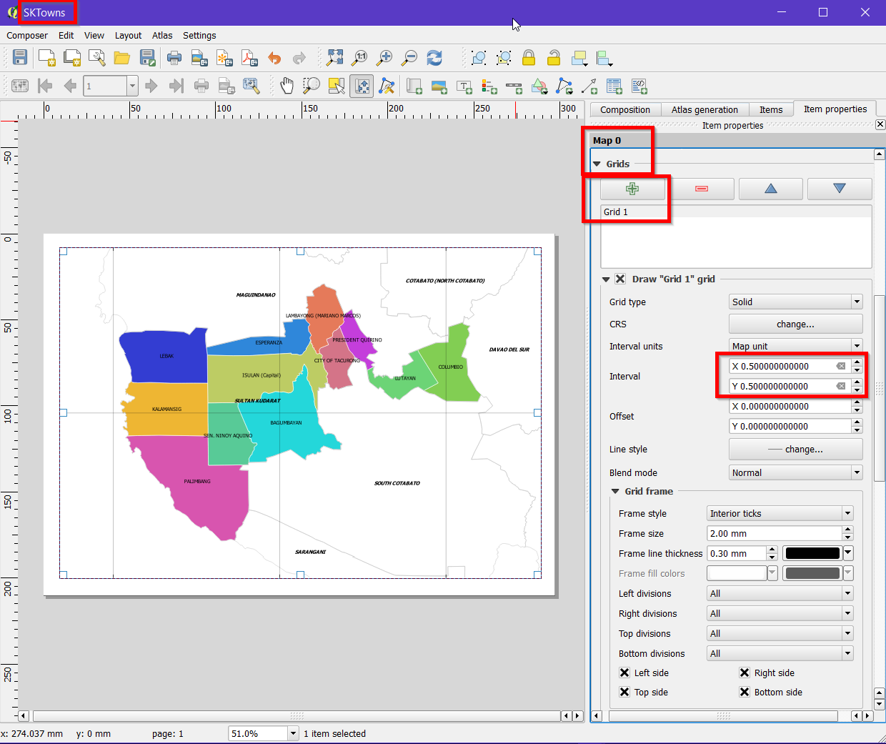

Draw grids.

You may use the Interval 0.5 degree instead of 1.0 to add more grids.

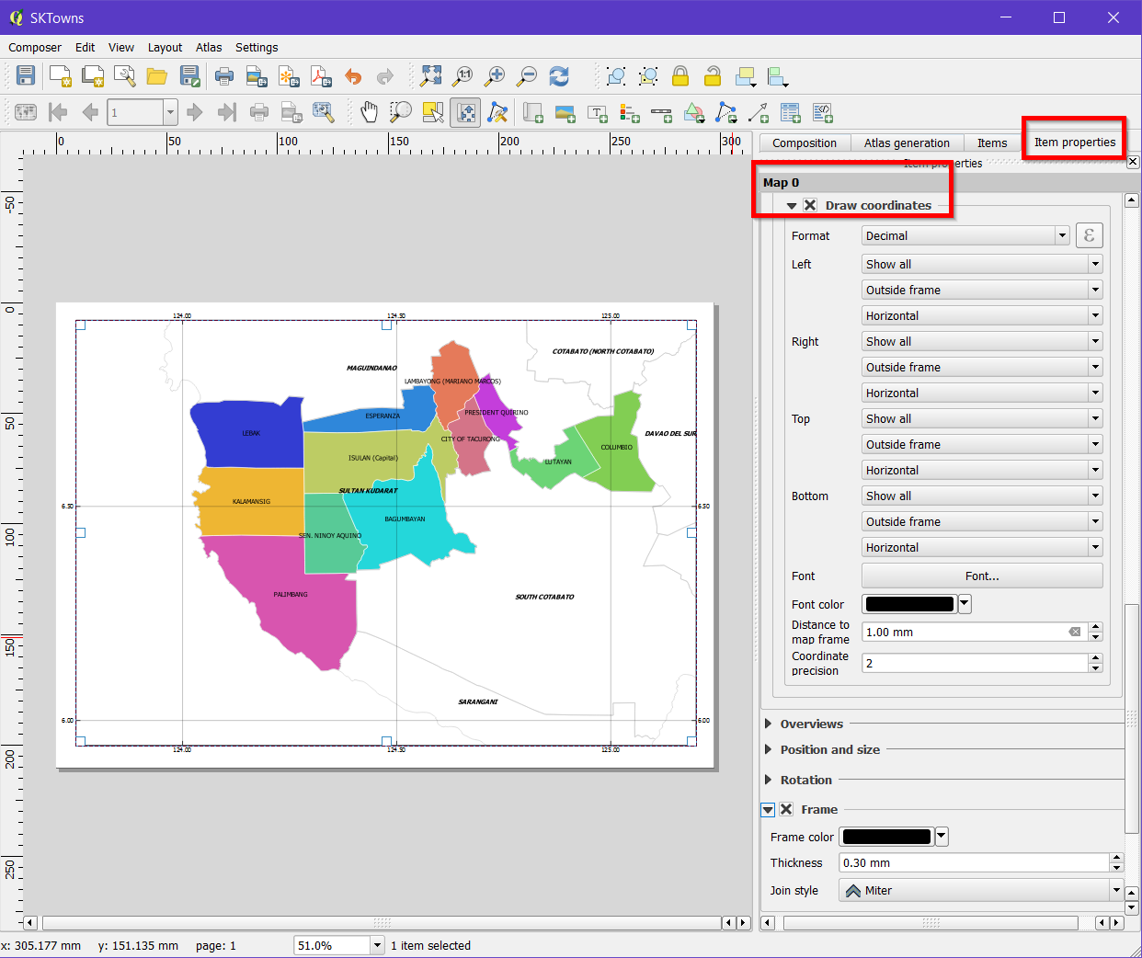

Draw coordinates and frame.

Add Scale Bar, North Arrow, Legend, and Title.

Click the Scale Bar tool. The Scale Bar window automatically appears.

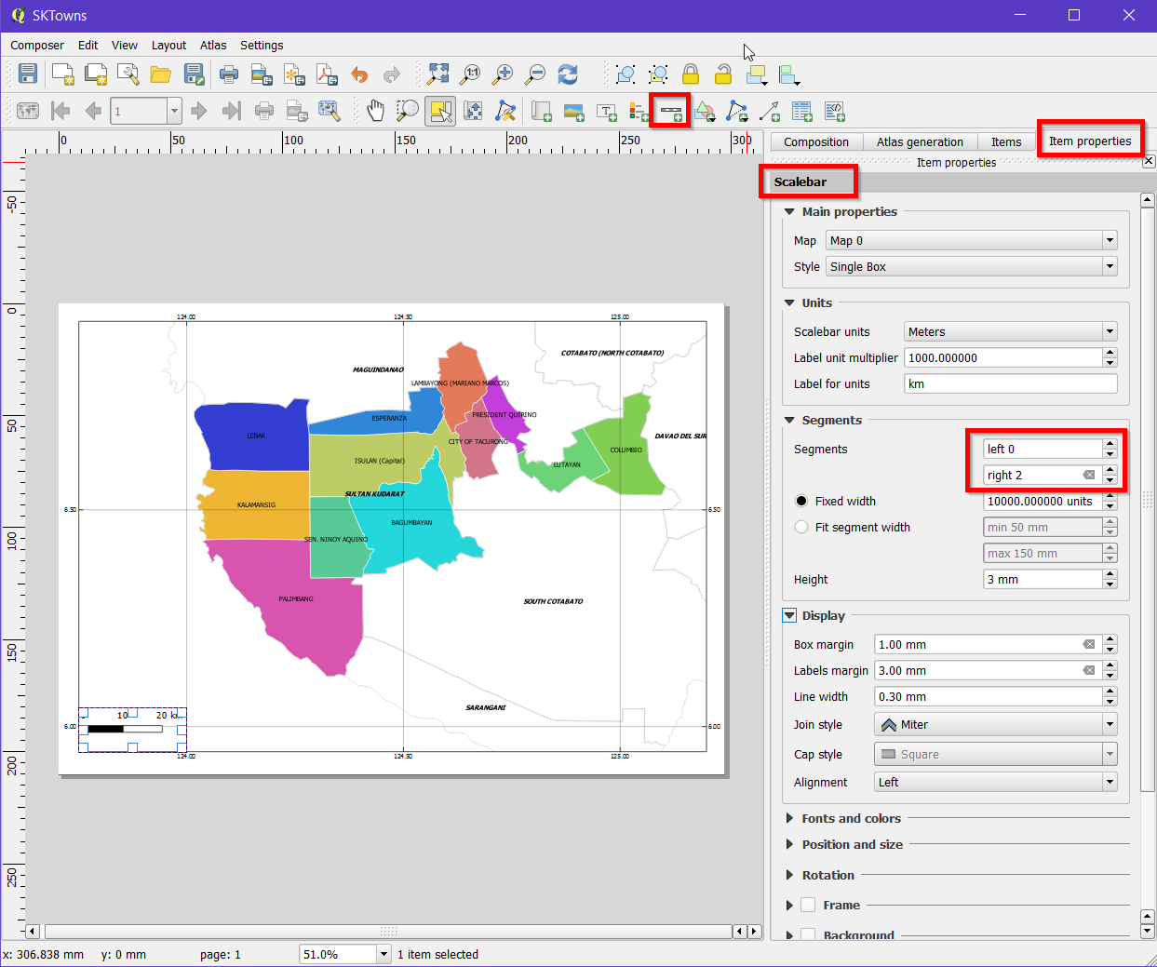

Add Label.

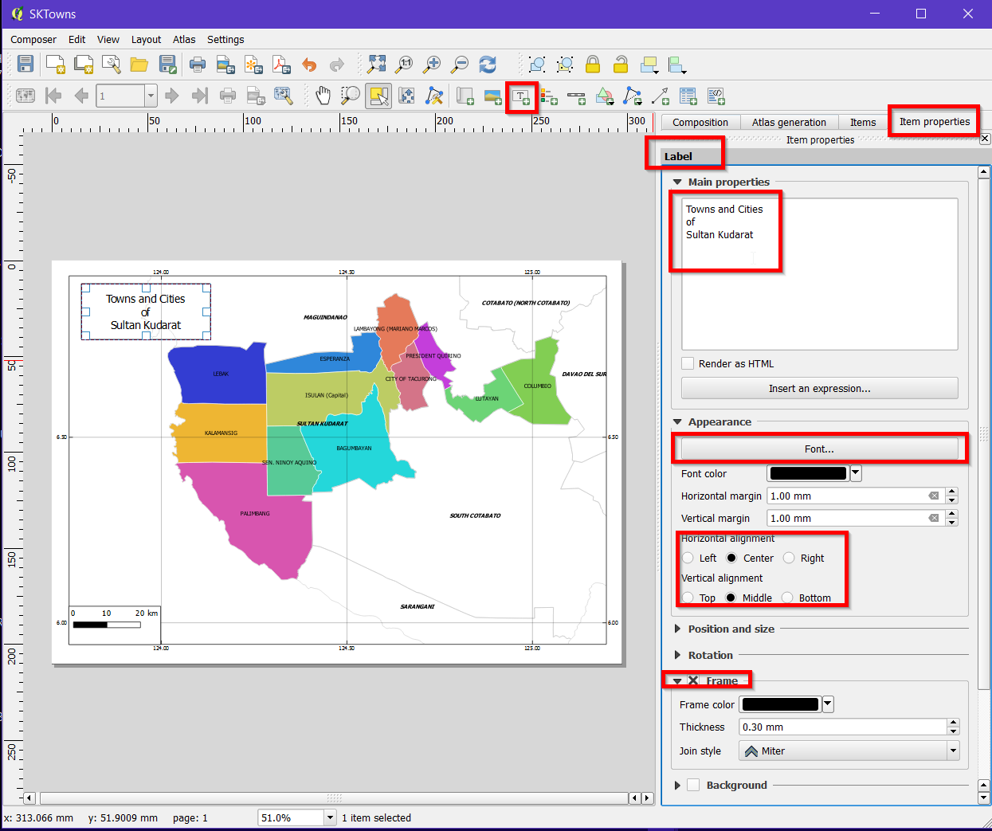

Add Legend.

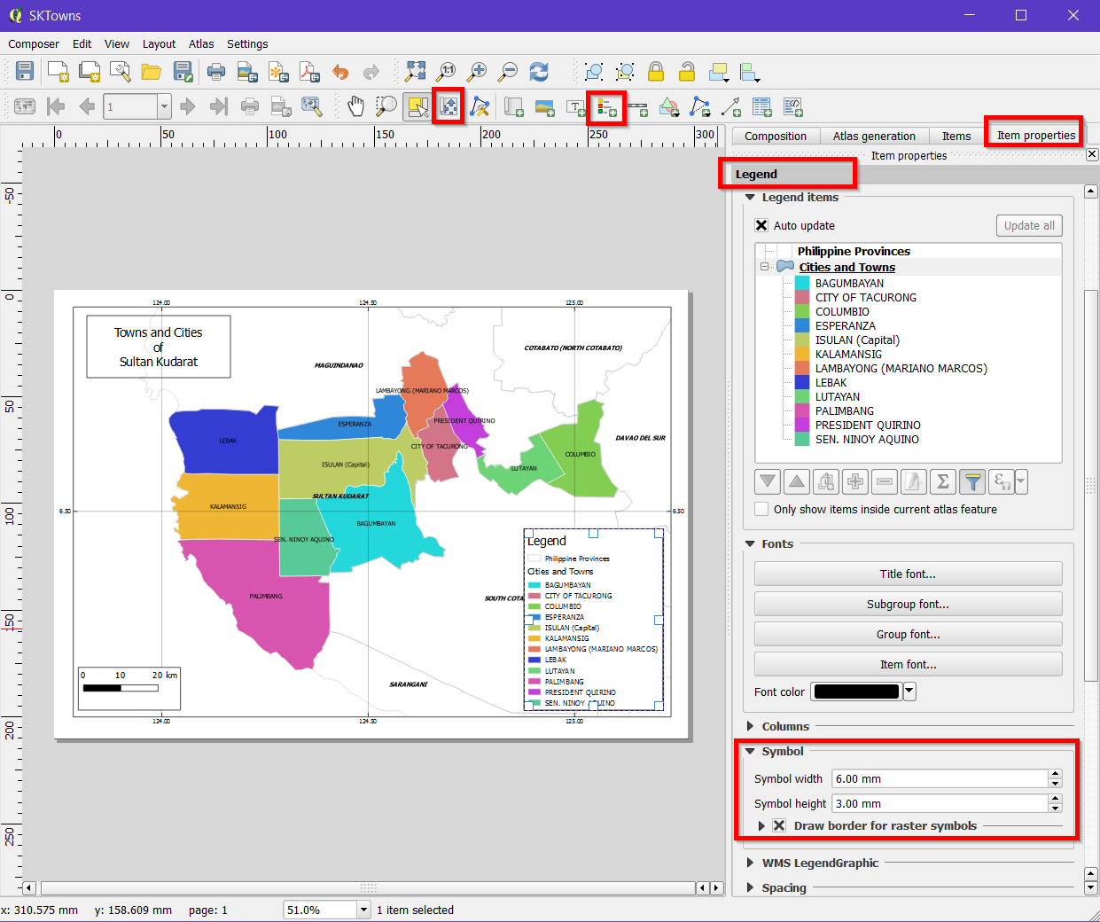

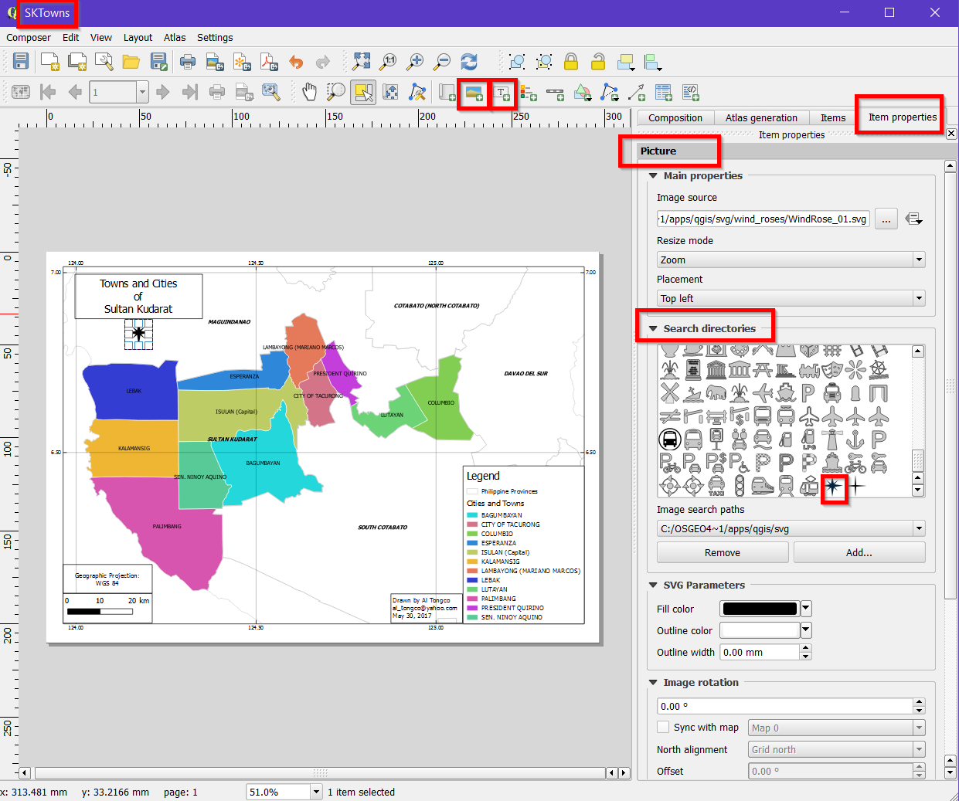

*Hint:* In Composer, click ‘Add Arrow’ tool then drag your cursor on the map. Or, you may use ‘Add Image’ tool to add a fancy-looking North Arrow (i.e. Item Properties tab > Search directories).

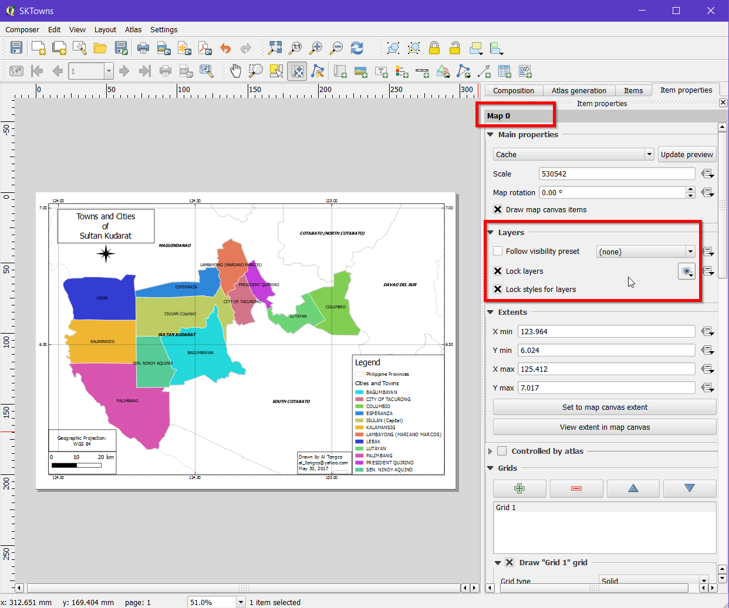

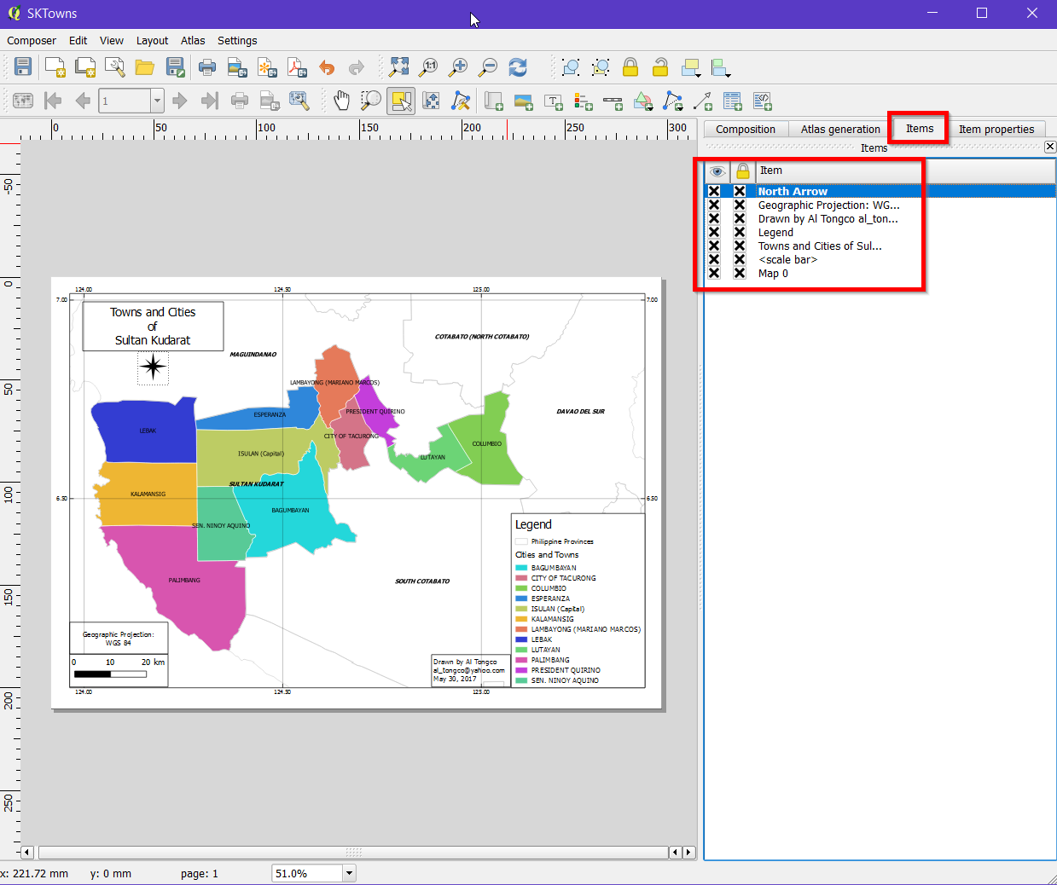

In QGIS modify the canvas, as follows:

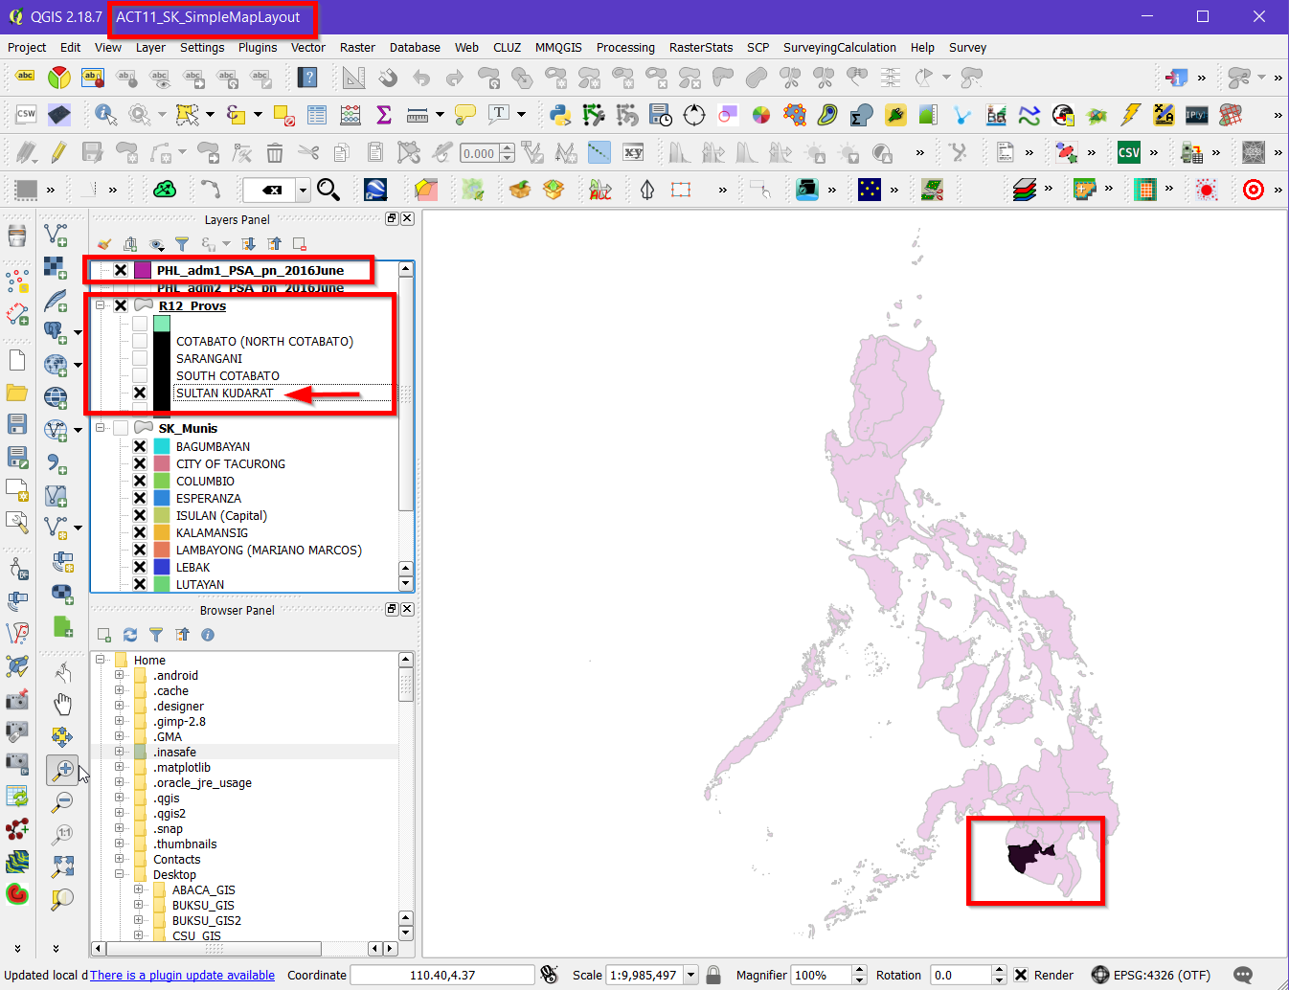

Add new map.

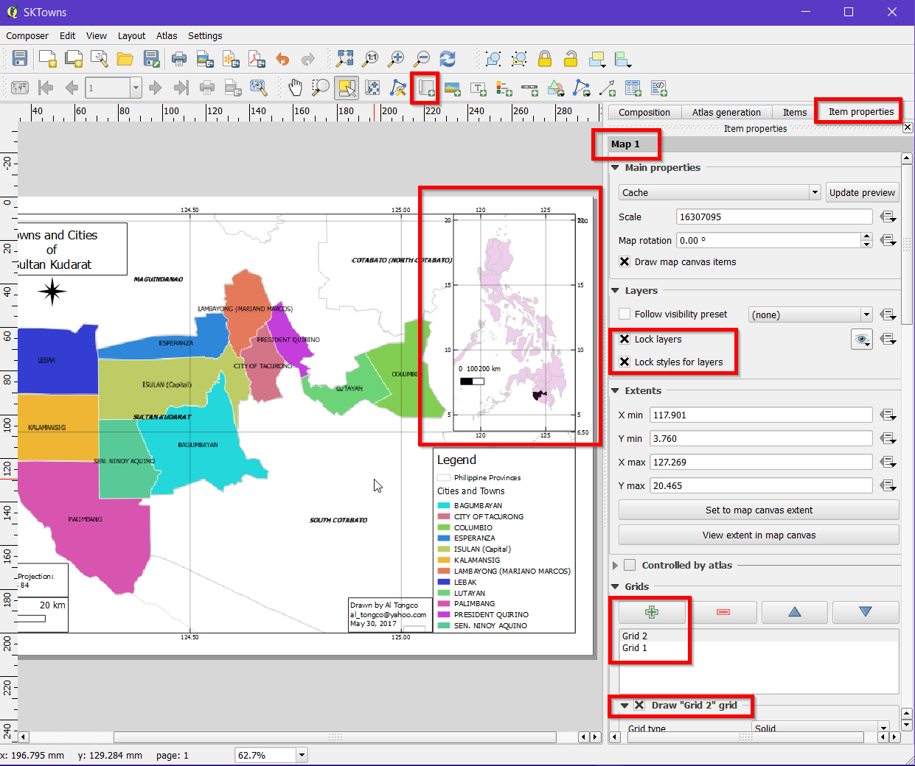

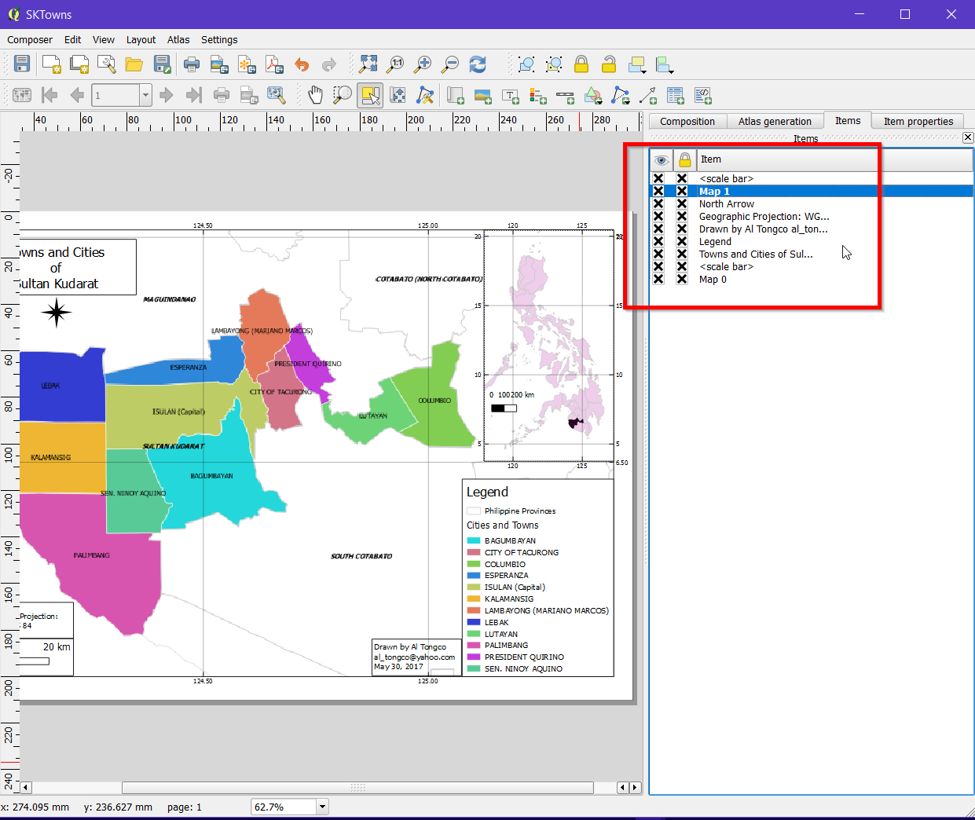

Once the main map looks OK, lock it.

The Composer may look like the one above.

Save Project.

Click Composer > Export as Image. Name: **SL\_Layout.tif**. Save in in C:\…..\OUTPUT\RASTERS\

Add SL\_**Layout.tif** to QGIS and observe what happens.

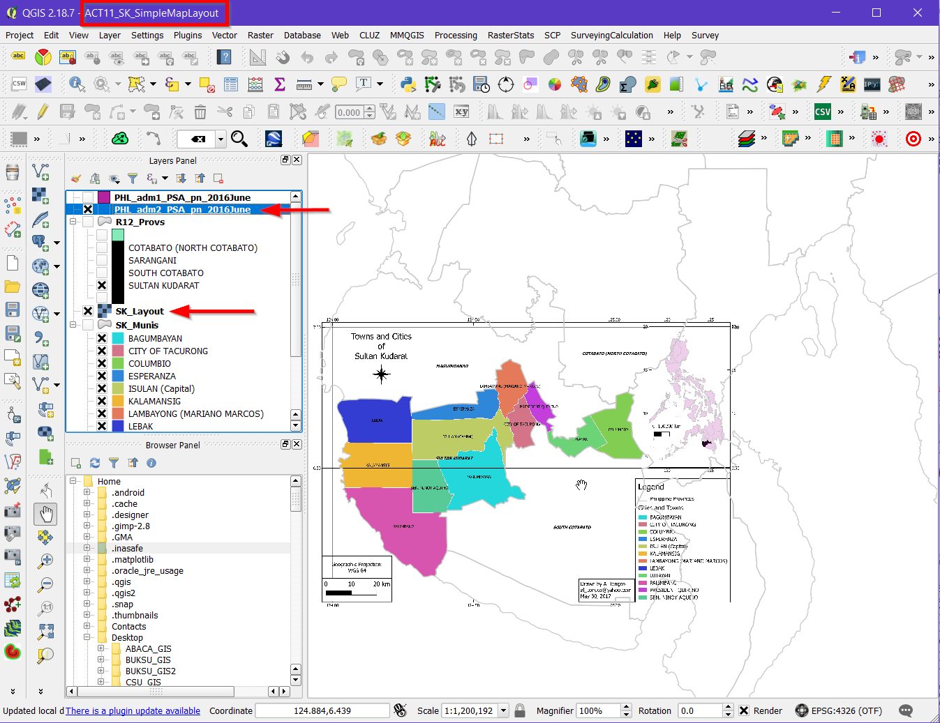

Insert **SL\_Layout.tif** here.

SK_Layout

-------------------------------------------------------------------------------------------------------

EXTRA CHALLENGE:

Add copyright.

-------------------------------------------------------------------------------------------------------

Save Project. Quit QGIS.

End of Exercise.